

**Computer Science and Engineering**

### ______________________________________________________

**Pitch’n**

**System Requirements Specification (SRS)**

**Version 1.2**

Document Number: SRS-001

Project Team Number: A10

Project Team Members: Avik Gomes (aag668), Tanya Jain (tj968), Crystal Song (cs5489)

**REVIEWS AND APPROVALS**

|  |  |  |  |
| --- | --- | --- | --- |
| **<Team Members>** | **Function (Author, Reviewer, Approval)** | **Date** | **Signature** |
| Avik Gomes | Author | 10/6/20 | On file |
| Crystal Song | Author | 10/6/20 | On file |
| Tanya Jain | Author | 10/6/20 | On file |
|  |  |  |  |
|  |  |  |  |
|  |  |  |  |
|  |  |  |  |

**REVISION LEVEL**

|  |  |  |
| --- | --- | --- |
| **Date** | **Revision Number** | **Purpose** |
| 10/6/20 | Version 1.0 | Initial Release |
| 10/22/20 | Version 1.1 | Include sections 6,7, and 8 |
| 11/18/20 | Version 1.2 | Include section 9 |
|  |  |  |
|  |  |  |
|  |  |  |
|  |  |  |

**TABLE OF CONTENTS**

1. **DOCUMENT PURPOSE ................................................................................................ 1**
   1. PURPOSE .......................................................................................................................... 1
2. **INTRODUCTION ........................................................................................................... 1**
   1. SCOPE ............................................................................................................................... 1
   2. IDENTIFICATION ............................................................................................................ 1
   3. BOUNDS ........................................................................................................................... 2
   4. OBJECTIVES .................................................................................................................... 2
   5. CONTEXT DIAGRAM ..................................................................................................... 2
   6. ADDITIONAL DESCRIPTIVE ITEMS ........................................................................... 3
3. **GLOSSARY ......................................................................................................................4**
4. **REFERENCE DOCUMENTS .........................................................................................4**
5. **BUSINESS REQUIREMENTS ...................................................................................... 4**
   1. TECHNOLOGY ................................................................................................................ 4
   2. ECONOMICS .................................................................................................................... 4
   3. REGULATORY AND LEGAL ......................................................................................... 4
   4. MARKET CONSIDERATIONS ....................................................................................... 4
   5. RISKS AND ALTERNATIVES ........................................................................................ 5
   6. HUMAN RESOURCES AND TRAINING ...................................................................... 5
6. **USER REQUIREMENTS (DESCRIPTIVE FUNCTIONAL AND NON-FUNCTIONAL REQUIREMENTS) ..............................................................................5**
   1. FUNCTIONAL DESCRIPTIVE DETAILED REQUIREMENTS ................................... 5
   2. NON-FUNCTIONAL DESCRIPTIVE DETAILED REQUIREMENTS ......................... 5
7. **SYSTEM ARCHITECTURE ......................................................................................... 6**
8. **DETAILED SYSTEM REQUIREMENTS - USE CASES ...........................................6**
   1. REQUIREMENT USE CASES .........................................................................................6
9. **SYSTEM MODEL(UML) ………………………………………………………………9**
   1. STATIC – CLASS DIAGRAMS.........................................................................................9
   2. DYNAMIC – BEHAVIORAL MODELS……………………………………………….11
10. **EVOLUTION OF THE SRS ..........................................................................................13**
11. **RATIONALE ..................................................................................................................13**
12. **NOTES .............................................................................................................................13**
13. **APPENDICES .................................................................................................................14**
    1. SYSTEM TEST PLAN REQUIREMENT .......................................................................14
    2. QUALIFICATION PROVISIONS ...................................................................................14
    3. REQUIREMENTS TRACEABILITY…………………………………………………...15
    4. SCHEDULE TRACKING ................................................................................................15
    5. DEFECT TRACKING ......................................................................................................16
    6. DICTIONARIES…………………………………………………………………………17
14. **INDEX.............................................................................................................................. 19**

# **DOCUMENT PURPOSE**

|  |
| --- |
|  |

**1.1 Purpose**

The purpose of this software requirements document is to clearly define the system under development, namely the Pitch’n system. The intended audience of this document includes the users who are looking to donate items and donation centers who are looking to receive items. Other intended audience includes the development team such as the requirements team, requirements analyst, design team, and other members of the developing organization.

# **INTRODUCTION**

|  |
| --- |
|  |

The Pitch’n system will include an application that tells the user where to donate and what is needed to be donated. Donation Centers will be able to state what they want to be donated, their location and other company information.

Other applications allow the user to donate money to the donation center/charity, while Pitch’n also lets the users know what else they can donate to help.

**2.1 Scope**

The owner of a local shelter wanted to create an online medium for users to be able to see what things shelters need and accept, their operating hours, and their location. Therefore, the Pitch’n system will include the following functionality: information on donation centers, and a system for donors to access this information. Pitch’n is intended to make donating easy and fun, and make the jobs for the centers a bit easier.

**2.2 Identification**

Pitch’n System Requirements Specification, SRS-001, Version 1.1

**2.3 Bounds**

The donators use Pitch’n to get general information about Donation Centers near them, and to see what they need to be donated. While the Donation centers upload their general information and what they need, and find out who is donating what.

**2.4 Objectives**

Our project priority includes identifying the donation centers and providing those locations to nearby users who want to donate items. The life cycle of our project will be evolutionary as we will continue to develop and update our application with ongoing user feedback.

Software Requirement and Analysis Specification (SRS-Requirements): October 20, 2020

Software Project Management Plan (SPMP): November 5, 2020

Software Analysis Specification - Final (SRS - Analysis): November 17, 2020

Project Presentation: December 10, 2020

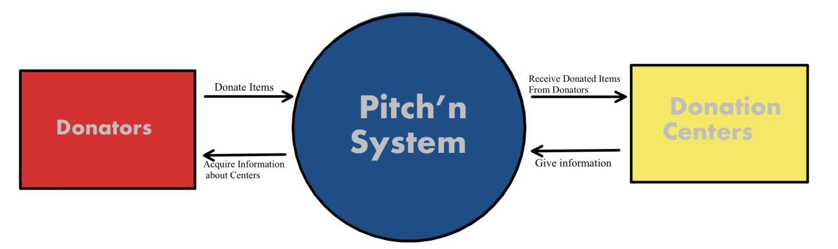**2.5 Context Diagram**

**2.6 Additional Descriptive Items**

1. Product functions:
   * A maps system to track user’s location, and store and display nearby centers to them
   * Profile system to display each center’s information such as items they accept and hours of operation.
   * Contact system to let users contact the centers directly.
2. User Characteristics
   * Knowledge about GPS services so they can successfully locate the centers.
   * Experience with donating
   * Technical knowledge about applications
3. Constraints
   * Will have to request access to users’ location. However, not all users would want to share their location.
   * All locations and information need to be correct
   * Need to ensure all directions are safe
   * Software needs to be accessible on all devices
   * Friendly and easy to use interface
   * Centers need to give developers permissions for their information to be displayed
4. Assumptions and dependencies – list each of the factors that affect the requirements. These factors are not design constraints; rather, any changes to them that can affect the requirements. (For example, the specification of a specific operating system on a particular hardware platform. If the OS or hardware were not available, the requirements would have to be modified)
   * If users disable their location services, the search results would have to be modified.
5. Requirements subsets – For iterative development, identify requirements subsets and those requirements subsets that could be delayed until future releases.
   * A chat feature for users to directly contact the centers through Pitch’n(could be delayed until future release).
   * Provide a means to transport the items from users to the centers (could be delayed until future release).

# **GLOSSARY**

|  |
| --- |
|  |

# **Donators:**

Users who are donating to the Donation Centers

**Donation Centers:**

Clients who want to make known of what they need to be donated

# **REFERENCE DOCUMENTS**

|  |
| --- |
| [***Project Proposal***](https://docs.google.com/document/d/1Nf-9h8qLjwBnfbRC94q8wTwslFnsJstanIRl50SqZgw/edit?usp=sharing)  A10; Project Team Proposal; 01; Version-01; September 21, 2020 |

# **BUSINESS REQUIREMENTS**

|  |
| --- |
|  |

**5.1 Technology**

None

**5.2 Economics**

Helping Donation Centers receive items they need to give the needy. This has the chance to help those in need get their lives back inorder and get jobs.

**5.3 Regulatory and Legal**

None

**5.4 Market Considerations**

Donation Centers

**5.5 Risks and Alternatives**

If there is some kind of natural disaster (i.e. Hurricane, Tornado, Blizzard, Pandemic. etc.) that restricts people from going outside then they cannot go to Donation Centers to donate items. As of now no alternative is found to resolve this issue.

**5.6 Human Resources and Training**

None

# **USER REQUIREMENTS (DESCRIPTIVE FUNCTIONAL AND NON-FUNCTIONAL REQUIREMENTS)**

|  |
| --- |
|  |

**6.1   Functional Descriptive Detailed Requirements**

Pitch’n system shall be able to locate donation centers within 10 miles of the user’s location when the application is opened.

A user shall be able to bookmark any donation center that is shown.

A user will be able to bookmark items from a certain donation center.

The Pitch’n system shall connect to the Google Maps API.

**6.2   Non-Functional Descriptive Detailed Requirements**

No false information is displayed for any center, thus when the demand for items change that information shall be updated

The center’s information should be displayed in 0.5 secs

# **SYSTEM ARCHITECTURE**

|  |
| --- |
|  |

Pitch’n will use the Google Maps Platform for our donators to know where the centers are and display the centers information when that center is pressed upon.

# **DETAILED SYSTEM REQUIREMENTS - USE CASES**

|  |
| --- |
|  |

**8.1   Requirement Use Cases**

**8.1.1 Use Case Diagrams**

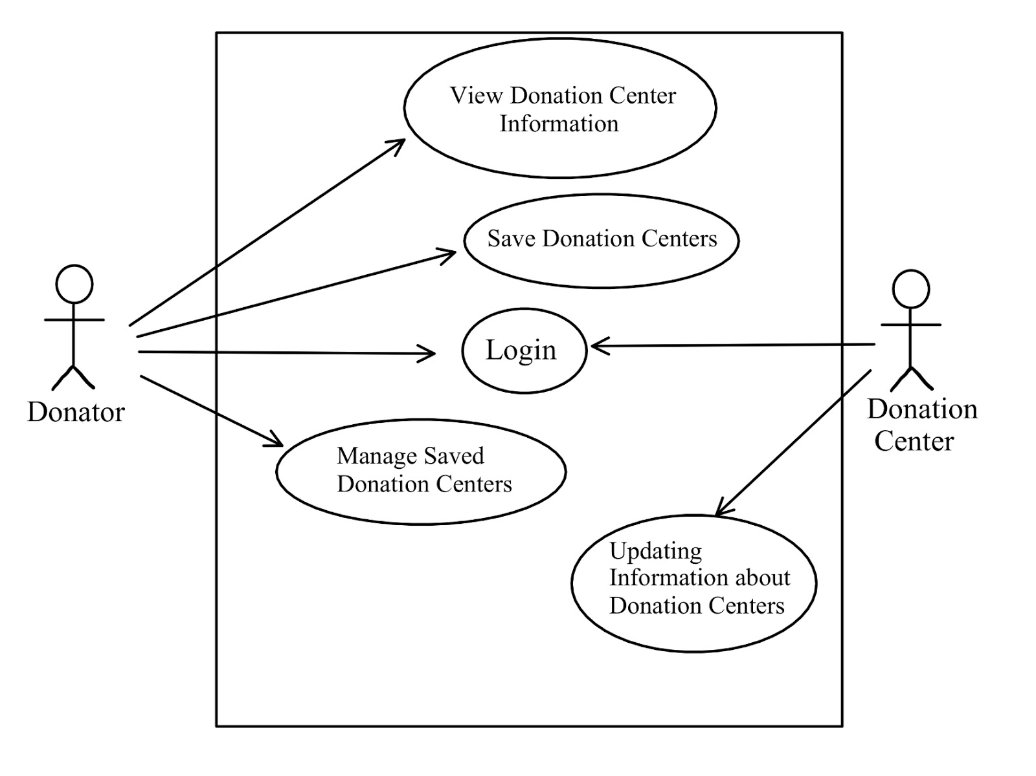

**8.1.2 Use Case Descriptions**

|  |  |  |
| --- | --- | --- |
| **View Donation Center Information** | | |
| **Description** | The user selects a donation center on the map | |
| **Pre-Conditions** | The user accepts permissions to access their location information | |
| **Flows** | **Basic or Normal Flows** | 1. The system provides the database information on the selected location |
|  | **Alternative Flows** | None |
| **Post Conditions** | The user is on the donation center information page | |
| **Special Requirements** | Must already have a donator account | |
| **Extension Points** | None | |

|  |  |  |
| --- | --- | --- |
| **Save Donation Center** | | |
| **Description** | The user clicks on the star | |
| **Pre-Conditions** | The user has accessed the view donation center information | |
| **Flows** | **Basic or Normal Flows** | 1. The system asks the user to confirm their choice 2. The user confirms |
|  | **Alternative Flows** | None |
| **Post Conditions** | The database is updated | |
| **Special Requirements** | None | |
| **Extension Points** | None | |

|  |  |  |
| --- | --- | --- |
| **Manage Saved Donation Centers** | | |
| **Description** | The user can access saved information about Centers. | |
| **Pre-Conditions** | The user selects the *Favorites* link | |
| **Flows** | **Basic or Normal Flows** | 1. The system presents an alphabetical list of saved locations |
|  | **Alternative Flows** | In step 1, the user can choose to delete saved donation centers by clicking on the star or view the donation center information. |
| **Post Conditions** | The database is updated | |
| **Special Requirements** | Must already have a donator account | |
| **Extension Points** | None | |

|  |  |  |
| --- | --- | --- |
| **Inputting Updating Information about Donation Center** | | |
| **Description** | The user selects a *Edit Information* link | |
| **Pre-Conditions** | The user is on the page that displays their center information |  |
| **Flows** | **Basic or Normal Flows** | 1. The system shows the current information on the database regarding the center 2. The user selects the button at the bottom of the page to update their information 3. The system presents the database information in grid form for modification 4. The user updates the information and submits the form 5. The system checks that the required fields are not blank |
|  | **Alternative Flows** | In step 5, if any required field is blank, the user is instructed to add an entry. No validation for correctness is made. |
| **Post Conditions** | The database has been  updated | |
| **Special Requirements** | Must have a Donation Center Account | |
| **Extension Points** | None | |

# **SYSTEM MODEL (UML)**

|  |
| --- |
|  |

# 9.1 **Static - Class Diagrams**

|  |
| --- |
| **Donator** |
| Id  Location |
| saveLocation(location) |

|  |
| --- |
| **Donation Center** |
| Name  Address  DesiredItems  OpenTimes |
| editInfo() |

|  |
| --- |
| **Favorites** |
| savedLocations, type = list of pointers |
| addLocation(location)  removeLocation(location) |

# 

# 

# **9.2 Dynamic - Behavioral Models**

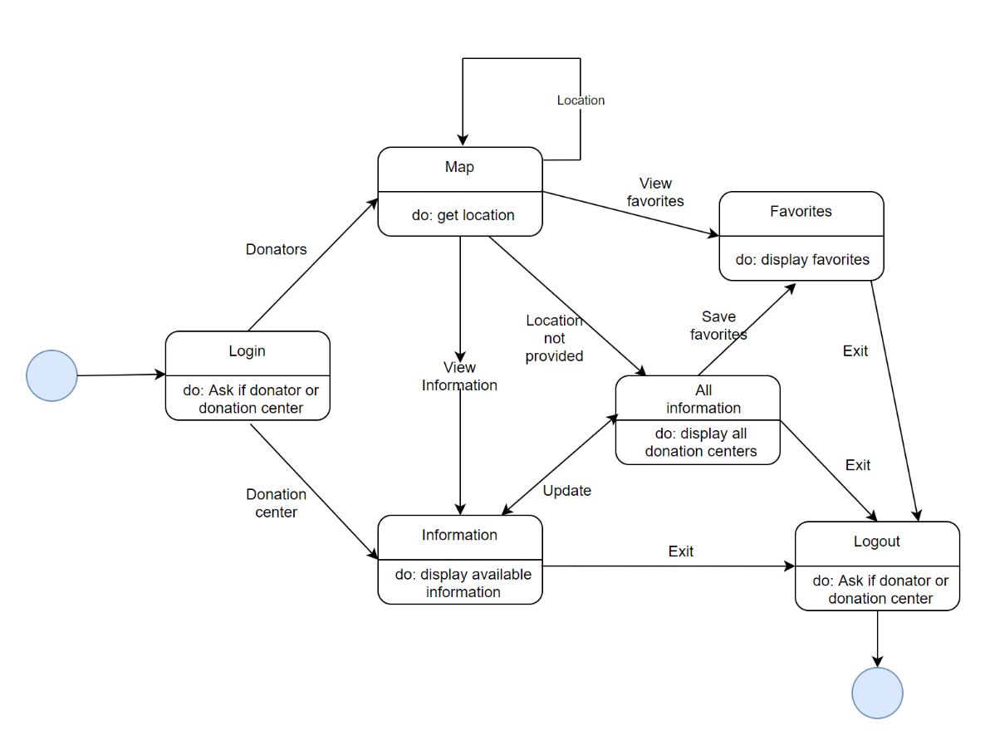

[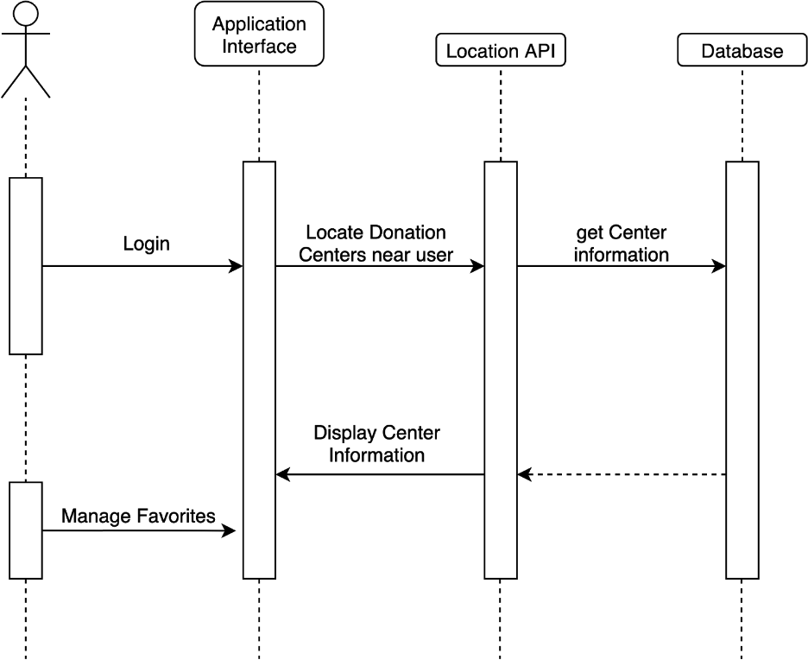](https://app.diagrams.net/?page-id=wtf7rAF7Xku1rpAyQQLs&scale=auto#G1wW47QVKdjmzcE372mRc-ygAuoLFdM8Sy)

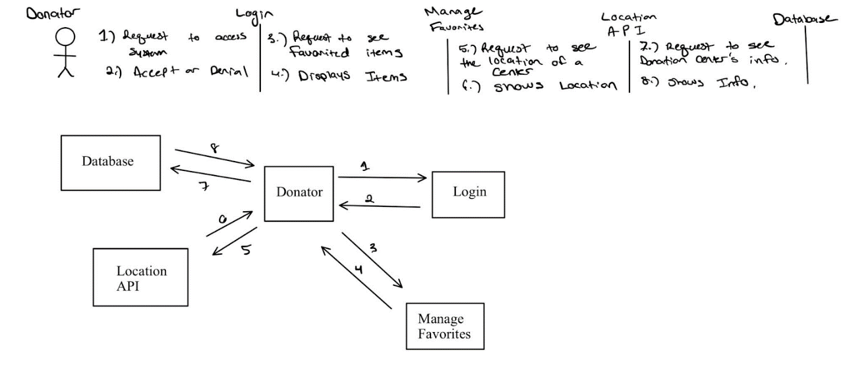

# **EVOLUTION OF THE SRS**

|  |
| --- |
|  |

As of now the SRS shows the initial plans for Pitch’n. As time progresses, and deliverables are made the SRS will be revised as needed. This includes information that states where Pitch’n is now, what needs to be done, and whether any expectancies occurred.

# **RATIONALE**

|  |
| --- |
|  |

# None

# **NOTES**

|  |
| --- |
| None |

# **APPENDICES**

|  |
| --- |
|  |

# **13.1 System Test Plan Requirements**

We will initially be testing each individual section of the application. Beginning with the identification of donation centers in a location near a user, we will be using random locations to simulate users. The software should be able to locate nearby donation centers such as homeless shelters, soup kitchens, etc. without identifying other locations. Subsequent testing will include the ease with which the user can navigate the interface by having testers try out the software and locate any errors. Once the product is released, we will be referring to reviews and ratings of the application made by users in order to direct any future development.

**13.2 Qualification Provisions**

Pitch’n will be qualified through formal validation tests of the SRS level requirements. The Qualification Methods applied to the software shall include test, peer review, walk-through, and inspection.

* 1. TEST (SELF-CHECK)
     1. A qualification method that is carried out by operation of the system and that relies on the collection and subsequent examination of data
  2. PEER REVIEW
     1. A qualification method that is carried out by operation of the system, and that relies on observable functional operation not requiring the use of elaborate instrumentation or special test equipment.
  3. WALK-THROUGH
     1. A semi formal qualification method that is carried out by the processing of accumulated data. An example of accumulated data is the compilation of data obtained from other qualification methods. Examples of the processing of accumulated data are interpretations or extrapolations made from the data.
  4. INSPECTION
     1. A formal qualification method that is carried out by visual examination, physical manipulation, or measurement to verify that the requirements have been satisfied.

**13.3 Requirements Traceability**

Every requirement has a unique number which is traceable from the requirements to the analysis to the design. Reverse traceability also applies as one can take a requirement found in the code and trace it back to the actual requirement that came from it.

**13.4 Schedule Tracking**

|  |  |  |  |  |
| --- | --- | --- | --- | --- |
| Artifact or Deliverable | Who (individual or Team) | Estimated | Actual | Difference |
| Initial SRS | Avik Gomes, Tanya Jain,  Crystal Song | 4 hours | 2.5 hours | 1.5 hours |
| SRS-  Requirements | Avik Gomes, Tanya Jain,  Crystal Song | 2.5 hours | 1.5 hours | 1 hour |
| SRS-Analysis | Avik Gomes, Tanya Jain,  Crystal Song | 2 hours | 1.5 hours | .5 hours |

|  |  |  |  |  |
| --- | --- | --- | --- | --- |
| Artifact or Deliverable | Who (individual or Team) | Estimated | Actual | Difference |
| Final SRS |  |  |  |  |
|  |  |  |  |  |
|  |  |  |  |  |

**Cumulative**

|  |  |  |  |
| --- | --- | --- | --- |
| Who (individual or Team) | Estimated | Actual | Difference |
| Avik Gomes, Tanya Jain,  Crystal Song | 8.5 hours | 5.5 hours | 3 hours |

**13.5 Defect Tracking**

|  |  |  |  |  |
| --- | --- | --- | --- | --- |
| Artifact or Deliverable | Who (individual or Team) | Estimated | Actual | Difference |
| Initial SRS | Crystal Song, Avik Gomes, Tanya Jain | 3 | 3 | 0 |
| SRS-Requirements | Crystal Song, Avik Gomes, Tanya Jain | 3 | 2 | 1 |
| SRS-Analysis | Crystal Song, Avik Gomes, Tanya Jain | 0 | 0 | 0 |

|  |  |  |  |  |
| --- | --- | --- | --- | --- |
| Artifact or Deliverable | Who (individual or Team) | Estimated | Actual | Difference |
| Final SRS |  |  |  |  |
|  |  |  |  |  |
|  |  |  |  |  |

**Cumulative**

|  |  |  |  |
| --- | --- | --- | --- |
| Who (individual or Team) | Estimated | Actual | Difference |
|  |  |  |  |
|  |  |  |  |
|  |  |  |  |

**13.6 Dictionaries**

**Class**

|  |  |  |  |
| --- | --- | --- | --- |
| **Name** | **Description** | **Methods** | **Attributes** |
| Donator | Users who are donating to the Donation Centers. | Login  Give Location  Save Favorites |  |
| Donation Centers | Clients who want to make known of what they accept. | Login  Edit Info | Database |
| Favorites | Users can store their favorite donation centers under favorites | Review | SavedLocations |

**Methods**

|  |  |  |  |
| --- | --- | --- | --- |
| **Name** | **Description** | **Class** | **Arguments** |
| Login() | Used to enter the system | Donator and Donation Centers | Username  Password |
| Give Location() | Used to get the donators location to display centers near them | Donator | Location |
| Save Favorites() | Can be used by donors to save their favorite centers | Donator | Donation Center |
| Edit Info() | Used by donation centers to edit their information | Donation Centers | New Info |
| Review() | Used to leave comments/ratings for the donation centers. | Favorites | Comments |

**Attributes**

|  |  |  |  |  |
| --- | --- | --- | --- | --- |
| **Name** | **Description** | **C/S** | **SIze** | **R/W** |
| SavedLocations | A list of saved donation centers | Simple | A subset of the database. Small in size | R and W for donators |
| Database | A list of all donation centers | Complex | Large | R for donators  R and W for donation centers |

**Relationship**

|  |  |  |  |  |
| --- | --- | --- | --- | --- |
| **Name** | **Description** | **From Class** | **To class** | **Cardinality** |
| View info | Donators view the info posted by donation centers. | Donators | Donation Centers |  |

**Key Events**

|  |  |  |  |  |  |  |
| --- | --- | --- | --- | --- | --- | --- |
| **Name** | **Description** | **Motive** | **Action** | **Pre conditions** | **Post conditions** | **State change** |
| Selecting favorites | Donators save centers as favorites | Easy access | Saving a center as favorite | Donators check out a center and they like it | They can quickly access the center as it is a favorite. | Non-favorite to favorite |

# **INDEX**

|  |
| --- |
|  |

A

**APPENDICES**, 6

B

**BUSINESS REQUIREMENTS**, 4

D

**DOCUMENT PURPOSE**, 1

Donate, 1, 2, 5

Donation Centers, 1, 2, 4, 5

E

**EVOLUTION OF THE SRS**, 5

G

**GLOSSARY**, 4

I

**INTRODUCTION**, 1

N

**NOTES**, 6

P

Pitch’n, 1, 2, 4, 5, 7

R

**RATIONALE**, 6

**REFERENCE DOCUMENTS**, 4